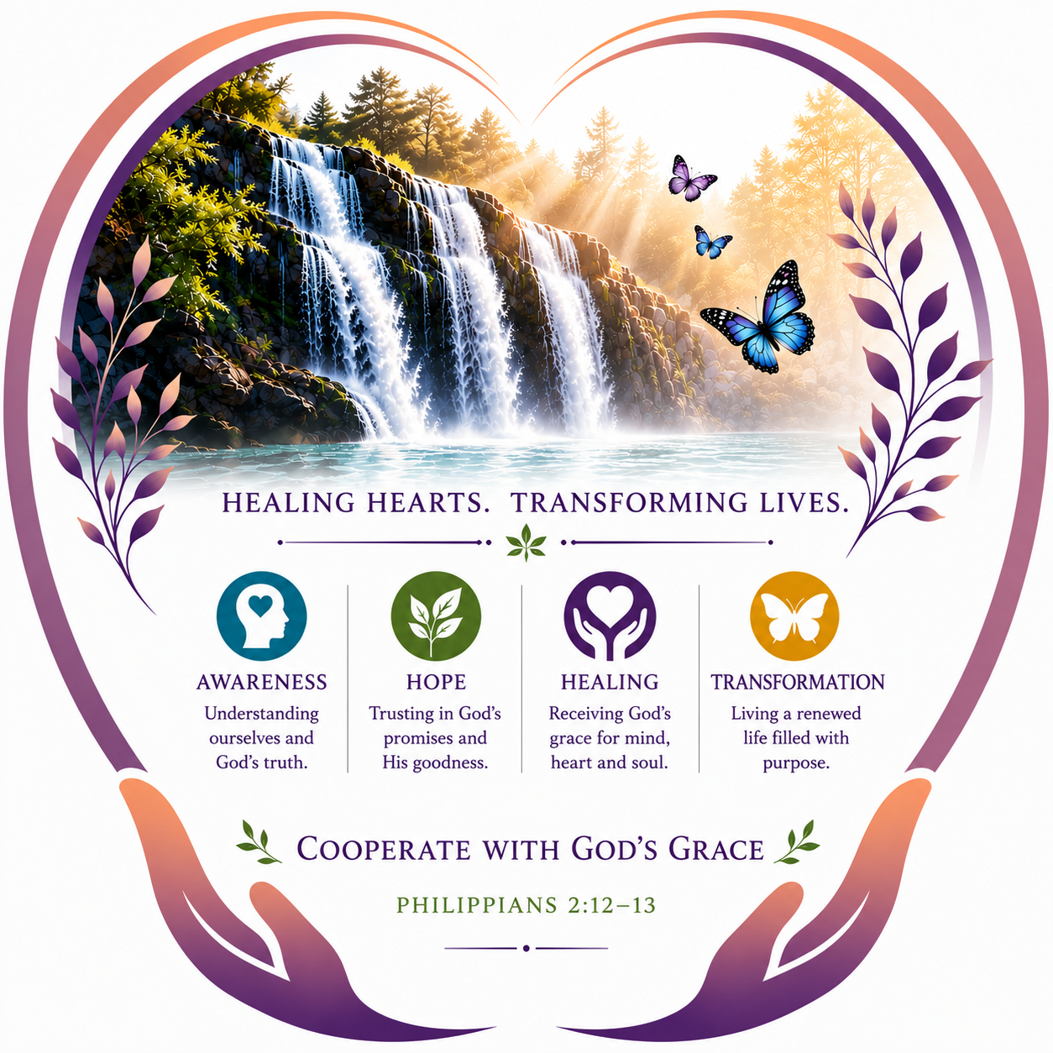

The Christian Anthropology of Healing
The Be Your Miracle Healing Model

Ten Foundational Principles

Principle | Reference | Scripture Text | Core Teaching | Healing Principle
1. Every Person Has Inherent Dignity | Genesis 1:27 | “So God created mankind in his own image, in the image of God he created them; male and female he created them.” | Every person is created in God’s image and possesses inherent dignity as a beloved child of God. Wounds, diagnoses, failures, behaviors, and circumstances do not define our deepest identity. | The person is never the problem. The person is a beloved child of God experiencing a problem.
2. God Is Already Present and at Work | Philippians 2:13 | “For it is God who works in you to will and to act in order to fulfill his good purpose.” | God is already present and at work within the person. Healing awakens us to His presence, grace, strengths, resilience, hope, and movements toward love. | We do not create grace; we learn to recognize and cooperate with where grace is already moving.
3. Healing Begins With Awareness—Without Judgment | John 8:32 | “Then you will know the truth, and the truth will set you free.” | Meaningful change begins by compassionately bringing thoughts, emotions, wounds, meanings, beliefs, reactions, and patterns into conscious awareness. | We cannot heal what we cannot see, and compassionate awareness creates space for grace, freedom, and healing.
4. Woundedness Is Not Identity | 2 Corinthians 5:17 | “Therefore, if anyone is in Christ, the new creation has come: The old has gone, the new is here!” | Trauma and woundedness may shape our story and create beliefs or patterns, but they do not define our God-given identity. We are beloved even as we grow in living from that belovedness. | My wounds are part of my story, but they are not the truth of who I am.
5. We Have a God-Given Capacity for Awareness, Freedom, and Response | Romans 12:2 | “Do not conform to the pattern of this world, but be transformed by the renewing of your mind.” | God gives us conscious awareness and free will. As awareness grows, we can pause, discern, and respond rather than automatically react from wounded patterns. | Between the thought and response lies awareness; within awareness lies freedom to respond to God’s invitation.

The Christian Anthropology of Healing
Principles 6–10
Principle | Reference | Scripture Text | Core Teaching | Healing Principle
6. Healing Involves the Whole Person | 1 Thessalonians 5:23 | “May God himself, the God of peace, sanctify you through and through. May your whole spirit, soul and body be kept blameless...” | God’s restoring grace engages the integrated human person—body, mind, emotions, relationships, and spirit. Woundedness in one dimension can affect the others. | Healing is movement toward wholeness, integration, and restoration of the whole person.
7. Healing Occurs Through Free Cooperation With God’s Grace | Philippians 2:12–13 | “Continue to work out your salvation with fear and trembling, for it is God who works in you to will and to act in order to fulfill his good purpose.” | God initiates and grace empowers, but love does not force. The Holy Spirit leads while we freely participate through awareness, choices, forgiveness, new practices, and surrender. | We are neither the source nor passive recipients of healing. Grace invites our free cooperation as participating disciples.
8. Surrender Opens Us More Fully to Grace and the Holy Spirit | Luke 22:42 | “Father, if you are willing, take this cup from me; yet not my will, but yours be done.” | Surrender is not passivity or giving up. It is freely releasing our need to control and entrusting ourselves to God, becoming more receptive to the Holy Spirit. | I participate fully, trust God, release the outcome, and remain open to the Spirit’s transforming grace.
9. We Become Vessels of God’s Grace and Love—and Participating Disciples | 2 Corinthians 1:3–5 | “The God of all comfort... comforts us in all our troubles, so that we can comfort those in any trouble with the comfort we ourselves receive from God.” | God is the true healer. As we cooperate with grace, we become increasingly available as vessels of God’s grace and love and as His hands and feet in the world. | God remains the source and the Holy Spirit the guide; our dignity is honored through the gift of participation.
10. Healing and Restoration Lead Toward Transformation Into Love and Joyful, Participating Discipleship | 2 Corinthians 3:18; Galatians 5:22–23 | “And we all... are being transformed into his image with ever-increasing glory, which comes from the Lord, who is the Spirit.”  “The fruit of the Spirit is love, joy, peace, forbearance, kindness, goodness, faithfulness, gentleness and self-control.” | The Holy Spirit continually heals, restores, and transforms us into greater freedom to love. The fruits of the Spirit become increasingly visible in our lives. | Joyful, participating discipleship is not a final destination, but an ever-deepening spiral of grace that continues to our last breath.

